

**Housing Price Prediction**

Submitted by: -

**AKSHAY DINESH SHAH**

**ACKNOWLEDGMENT**

* The data was collected by the company named Surprise Housing from the Sale of Houses in Australia.
* The company uses data analytics to purchase houses at a price below their actual values and flip them at a higher price.
* The company has collected a data set from the sale of houses in Australia in order to analyze and predict the sale prices.
* The company is looking at prospective properties to buy houses to enter the market

**INTRODUCTION**

* **Business Problem Framing**

To model the price of houses with the available independent variables. This model will then be used by the management to understand how exactly the prices vary with the variables. They can accordingly manipulate the strategy of the firm and concentrate on areas that will yield high returns. Further, the model will be a good way for the management to understand the pricing dynamics of a new market.

* **Conceptual Background of the Domain Problem**

Houses are one of the necessary needs of each and every person around the globe and therefore housing and real estate market is one of the markets which is one of the major contributors in the world’s economy. Companies can increase their overall revenue, profit by smartly investing in the houses with the right price. Using Data science, these companies can predict the prices of the house and invest the right amount on the house and sell them at a higher price.

* **Review of Literature**

In this project, the different features of the houses are analysed and the features that contribute more towards the price of the house are identified and are used to predict the house price. For this purpose, the dataset from the sale of houses in Australia is used.

There were missing values in many features which are imputed. PowerTransformer is used to fix the skewness of the data.

For scaling, MinMaxScaler is used. The dataset contains about 33% of outliers. Since it’s such a huge number, these outliers could just be natural outliers which won’t be an outlier if we have more data. The following features are dropped for specific reasons:  
1. LotFrontage has only 34% correlation with the SalePrice(target variable). Hence, it is dropped.

2. The YearBulit and the GarageYrBlt are highly correlated to each other. Hence, GarageYrBlt is dropped.

3. 1stFlrSF and TotalBsmtSF are highly correlated to each other. Hence dropped 1stFlrSF.

4. GrLivArea and TotRmsAbvGr are highly correlated to each other. Hence, dropped TotRmsAbvGr.

5. GarageCars and GarageArea are highly correlated to each other. Hence, dropped GarageArea.

6. Since Id is unique to each house, it has been dropped.

OneHotEncoder is used for encoding the categorical data so that any new values in the feature in test data or any future data can be ignored.

The Final hyperparameter tuned model chosen is the XGBRegressor model.

* The cross Val score of the final model with the whole train data is: **0.8827** and the Variance is: **0.000714**
* **Motivation for the Problem Undertaken**

Real Estate is a very popular domain for investment for many companies as well as many individuals. This project will help the companies/individuals to make the right decisions in terms of buying a house in Australia.

**Analytical Problem Framing**

* **Mathematical/ Analytical Modelling of the Problem**

Since the target value ‘Sale Price’ is a continuous variable, the problem is considered as a regression problem. Although there are some variables with good correlation, the linear models except Ridge did not perform well. The Ensemble models such as Gradient Boosting and Extreme Gradient Boosting techniques did a very good job in predicting the Sale price.

* Data Sources and their formats

The dataset was collected from the sale of houses in Australia. Data contains 1460 entries each having 81 variables.

The Variable data types are as follows:

Data columns (total 81 columns):

* # Column Non-Null Count Dtype
* --- ------ -------------- -----
* 0 Id 1168 non-null int64
* 1 MSSubClass 1168 non-null int64
* 2 MSZoning 1168 non-null object
* 3 LotFrontage 954 non-null float64
* 4 LotArea 1168 non-null int64
* 5 Street 1168 non-null object
* 6 Alley 77 non-null object
* 7 LotShape 1168 non-null object
* 8 LandContour 1168 non-null object
* 9 Utilities 1168 non-null object
* 10 LotConfig 1168 non-null object
* 11 LandSlope 1168 non-null object
* 12 Neighborhood 1168 non-null object
* 13 Condition1 1168 non-null object
* 14 Condition2 1168 non-null object
* 15 BldgType 1168 non-null object
* 16 HouseStyle 1168 non-null object
* 17 OverallQual 1168 non-null int64
* 18 OverallCond 1168 non-null int64
* 19 YearBuilt 1168 non-null int64
* 20 YearRemodAdd 1168 non-null int64
* 21 RoofStyle 1168 non-null object
* 22 RoofMatl 1168 non-null object
* 23 Exterior1st 1168 non-null object
* 24 Exterior2nd 1168 non-null object
* 25 MasVnrType 1161 non-null object
* 26 MasVnrArea 1161 non-null float64
* 27 ExterQual 1168 non-null object
* 28 ExterCond 1168 non-null object
* 29 Foundation 1168 non-null object
* 30 BsmtQual 1138 non-null object
* 31 BsmtCond 1138 non-null object
* 32 BsmtExposure 1137 non-null object
* 33 BsmtFinType1 1138 non-null object
* 34 BsmtFinSF1 1168 non-null int64
* 35 BsmtFinType2 1137 non-null object
* 36 BsmtFinSF2 1168 non-null int64
* 37 BsmtUnfSF 1168 non-null int64
* 38 TotalBsmtSF 1168 non-null int64
* 39 Heating 1168 non-null object
* 40 HeatingQC 1168 non-null object
* 41 CentralAir 1168 non-null object
* 42 Electrical 1168 non-null object
* 43 1stFlrSF 1168 non-null int64
* 44 2ndFlrSF 1168 non-null int64
* 45 LowQualFinSF 1168 non-null int64
* 46 GrLivArea 1168 non-null int64
* 47 BsmtFullBath 1168 non-null int64
* 48 BsmtHalfBath 1168 non-null int64
* 49 FullBath 1168 non-null int64
* 50 HalfBath 1168 non-null int64
* 51 BedroomAbvGr 1168 non-null int64
* 52 KitchenAbvGr 1168 non-null int64
* 53 KitchenQual 1168 non-null object
* 54 TotRmsAbvGrd 1168 non-null int64
* 55 Functional 1168 non-null object
* 56 Fireplaces 1168 non-null int64
* 57 FireplaceQu 617 non-null object
* 58 GarageType 1104 non-null object
* 59 GarageYrBlt 1104 non-null float64
* 60 GarageFinish 1104 non-null object
* 61 GarageCars 1168 non-null int64
* 62 GarageArea 1168 non-null int64
* 63 GarageQual 1104 non-null object
* 64 GarageCond 1104 non-null object
* 65 PavedDrive 1168 non-null object
* 66 WoodDeckSF 1168 non-null int64
* 67 OpenPorchSF 1168 non-null int64
* 68 EnclosedPorch 1168 non-null int64
* 69 3SsnPorch 1168 non-null int64
* 70 ScreenPorch 1168 non-null int64
* 71 PoolArea 1168 non-null int64
* 72 PoolQC 7 non-null object
* 73 Fence 237 non-null object
* 74 MiscFeature 44 non-null object
* 75 MiscVal 1168 non-null int64
* 76 MoSold 1168 non-null int64
* 77 YrSold 1168 non-null int64
* 78 SaleType 1168 non-null object
* 79 SaleCondition 1168 non-null object
* 80 SalePrice 1168 non-null int64
* dtypes: float64(3), int64(35), object(43)
* **Data Pre-processing Done**

The missing values in the categorical features are assumed to missing because that feature is not available for a house. The missing MasVnrArea is set to 0 because the values were missing for houses that did not have Masonary Veneer.

* **State the set of assumptions (if any) related to the problem under consideration**

Assumed that the missing categories are because the features were not available for the houses.

**Hardware and Software Requirements and Tools Used**

* Jupyter Notebook 6.1.4
* Pandas, NumPy – To analyse the data
* Matplotlib, Seaborn – To visualize the data
* SKLEARN
* PANDAS
* NUMPY

**Model/s Development and Evaluation**

* **Identification of possible problem-solving approaches (methods)**

This problem can be solved using Regression models. The R2 scores and Mean Squared Errors of different Base models and the ensemble models are compared, and the final best fit is used as the final model. The Final hyperparameter tuned model chosen is XGBRegressor model.

* **Testing of Identified Approaches (Algorithms)**

The following models were tried to solve this problem:

1. Lasso

2. Ridge

3. SVR

4. DecisionTreeRegressor

5. KNeighborsRegressor

* **Run and evaluate selected models**
* 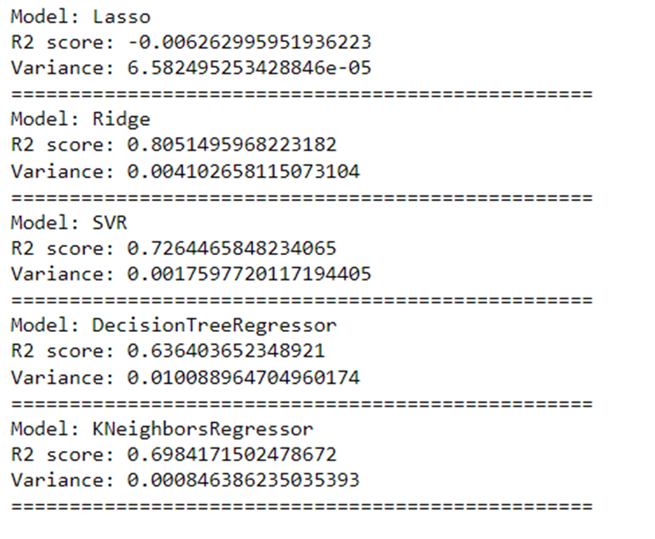

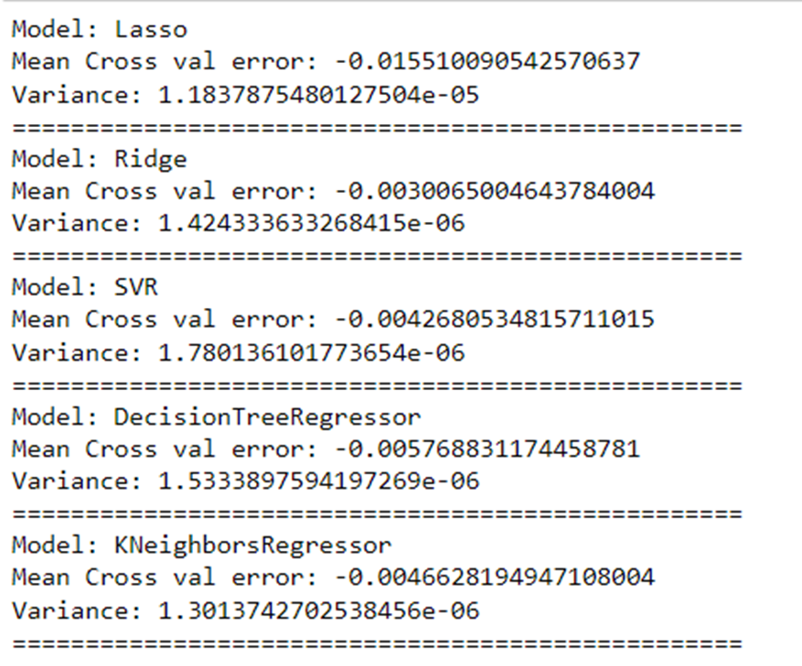

* **Key Metrics for success in solving problem under consideration.**

Since this is a regression problem, I used the R2 score and Mean Square Error as the Key metrics to find the best fitting model.

* **Data Visualizations**

1. **Correlation of features with target:**

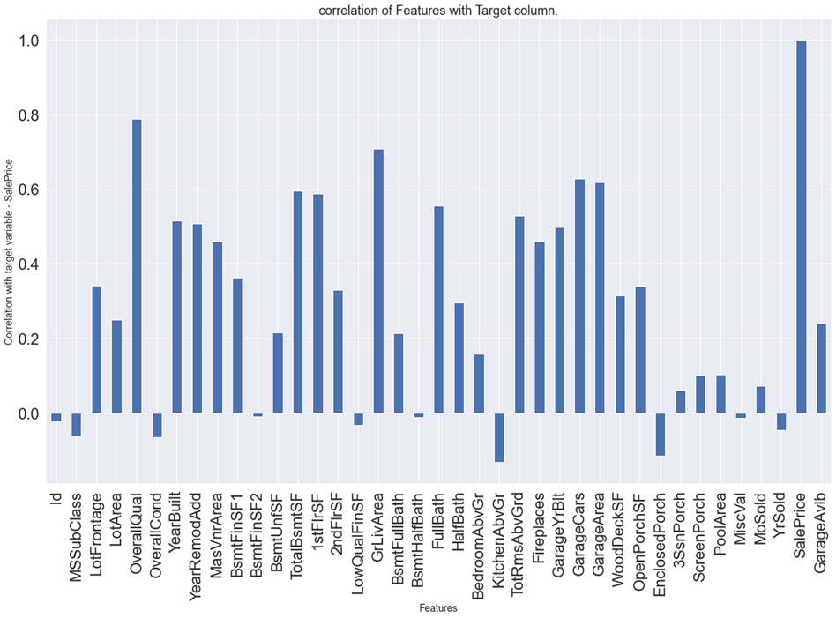

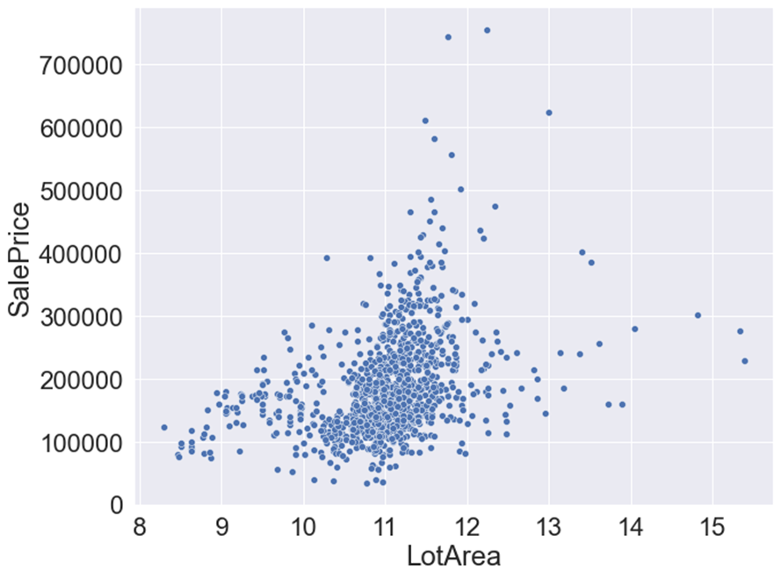

**FullBath vs SalePrice:**

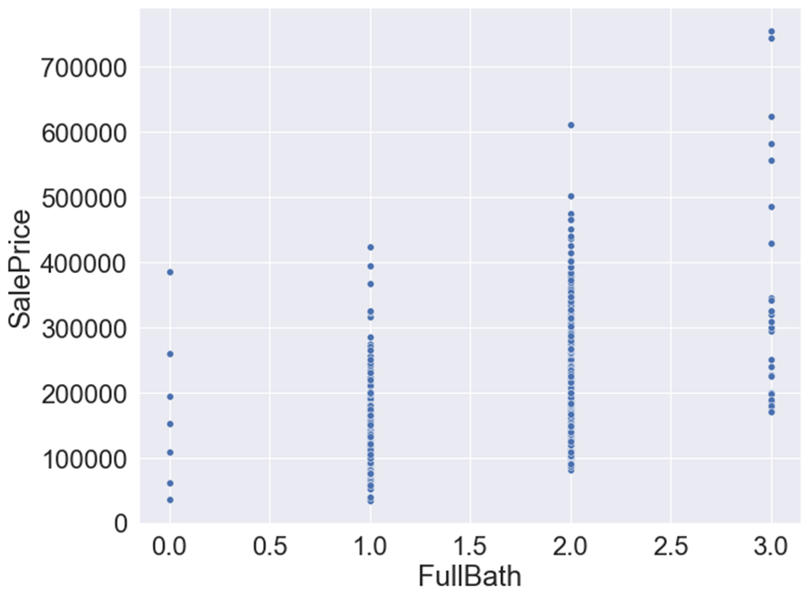

1. **OverallQual vs SalePrice:**

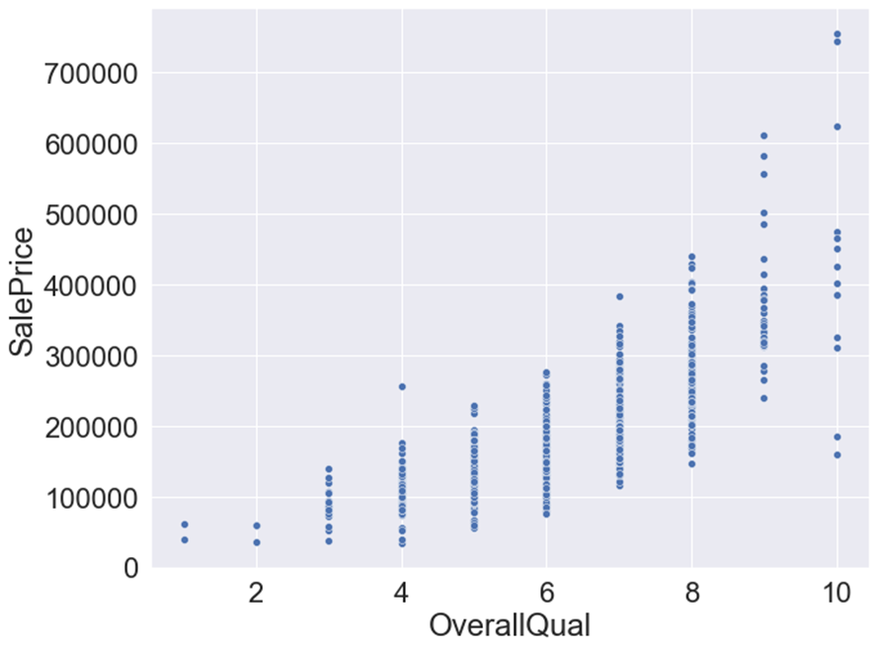

**Distribution of numerical features after transformation:**

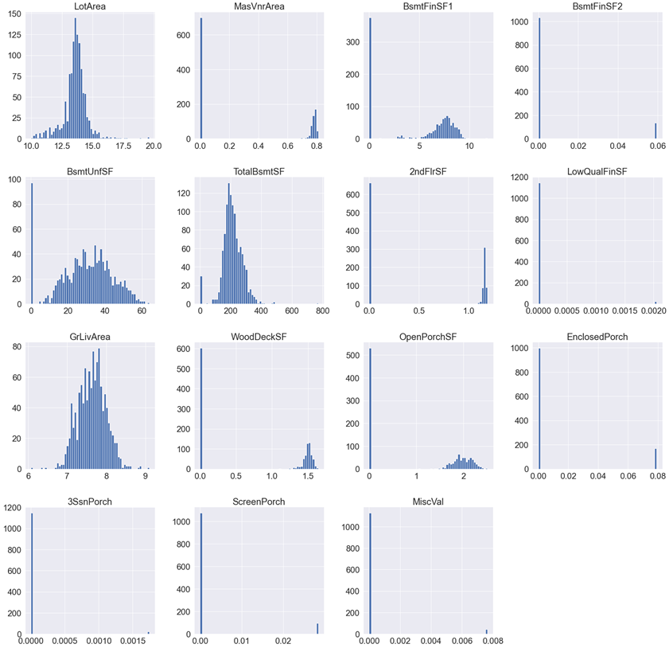

**Outliers:**

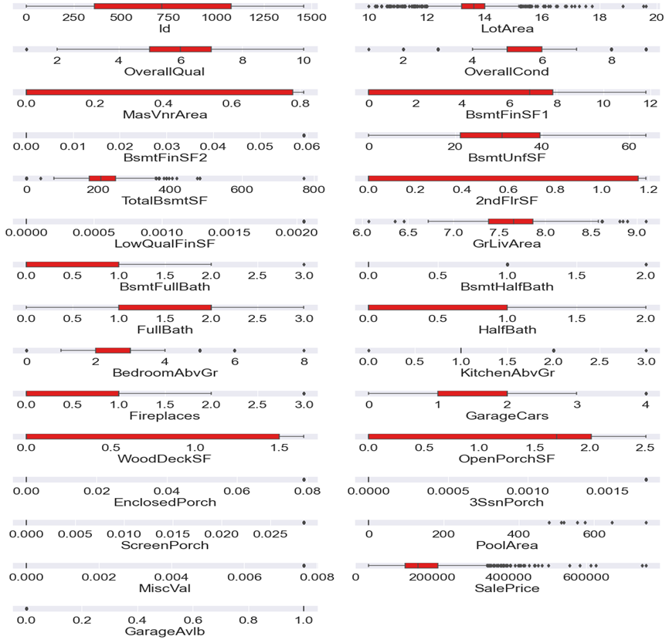

**Model comparison:**

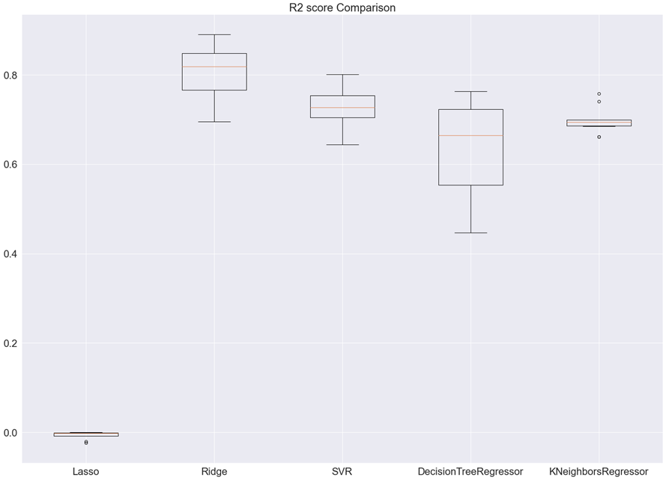

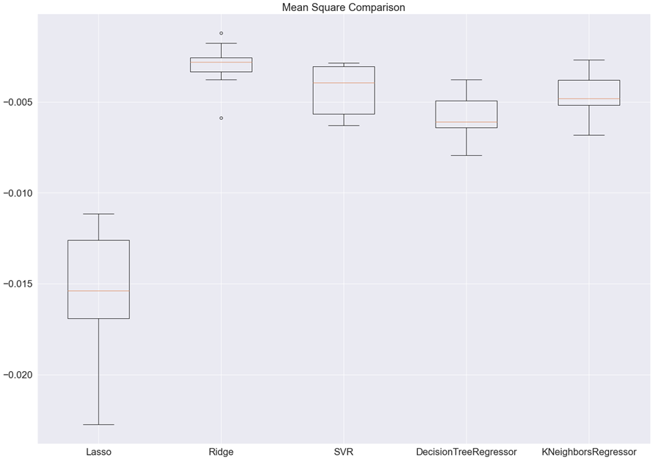

**Feature Importance considered by XGBRegressor model:**

* **Interpretation of the Results**

1.There was multi-correlation between some features

2.The OverallQual, GrLivArea, GarageCars, GarageArea, TotalBsmtSF, 1stFlrSF, FullBath are some of the highly correlated features with the target variable.

1. OverallQual, FirePlaces, GrLivArea, TotalBsmtSF, GarageCars, FullBath, OverallCond, BsmtFinSF1, LotArea, BsmtFullBath and some of the encoded features are having influence in predicting the Saleprice while using XGBRegressor model as the Final model.

**CONCLUSION**

* Key Findings and Conclusions of the Study

The OverallQual, GrLivArea, GarageCars, GarageArea, TotalBsmtSF, 1stFlrSF, FullBath are some of the highly correlated features with the target variable.

OverallQual, FirePlaces, GrLivArea, TotalBsmtSF, GarageCars, FullBath, OverallCond, BsmtFinSF1, LotArea, BsmtFullBathare some of the most important features that influence the Sale Price of a house in Australia.

* **Learning Outcomes of the Study in respect of Data Science**

Changing the hyperparameter ranges based on the results will further improve the model performance.

* **Limitations of this work and Scope for Future Work**
* There are only few data for training. The model will perform better by training with more data in future.